

**SuperPoints User Guide**

Contents

Introduction: 3

Landing Page: 4

User Sign Up: 4

Business Sign Up: 4

Login: 4

Sign Up: 4

Regular Sign Up: 5

Business Sign Up: 6

Login: 7

Menu: 8

User: 10

Home: 10

Dashboard: 12

View Points: 13

Settings: 14

Business: 15

Business Dashboard: 15

Adding a Promotion: 16

Editing a Promotion: 17

Deleting a Promotion: 17

Analytics: 17

Settings: 19

Admin: 20

Dashboard: 20

Beacon Setup: 21

Settings: 22

# Introduction:

This user manual will go over all of the different ways that a user, business, and administrator of this app can interact with it. There will be a screenshot of each screen that a user can interact with, followed by an explanation of all of the different interactions available on that screen.

# Landing Page:

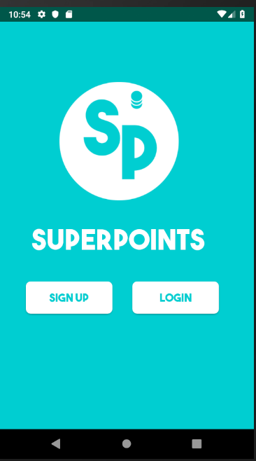

**Figure 1: Login Page**

# User Sign Up:

# Business Sign Up:

# Login:

# Sign Up:

Upon opening the app, the user is greeted by the landing page. Here, a user can choose to either sign up, or log in.

# Regular Sign Up:

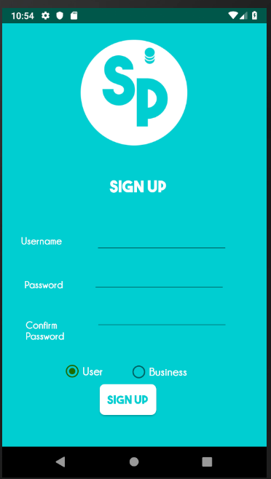

Sign Up Page

This page allows one to sign up as a user of the app or a Business. If one wants to sign up as a user, they have to fill in the username, password, and confirm password field. Lastly, they have to select the ‘User’ radio button. If someone wants to sign up as a business, they still have to fill in all of the fields, and make sure that they have highlighted the ‘Business’ radio button.

# Business Sign Up:

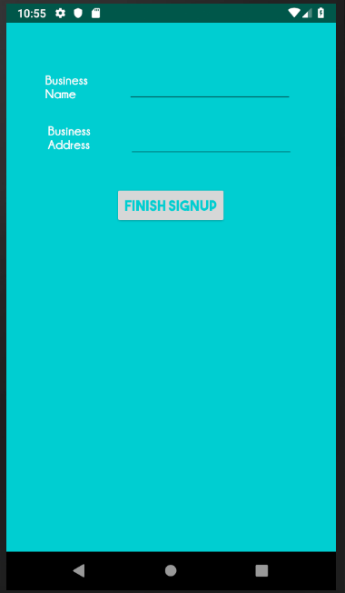

Business Signup page

If someone is registering their business, they will be taken onto this page to finish their registration process. On this page, the user will be asked to provide their Business name, as well as the address of their business. The address is required so that regular users of the app can view the business on the map, and so that the users can know to visit the business to receive super points.

# Login:

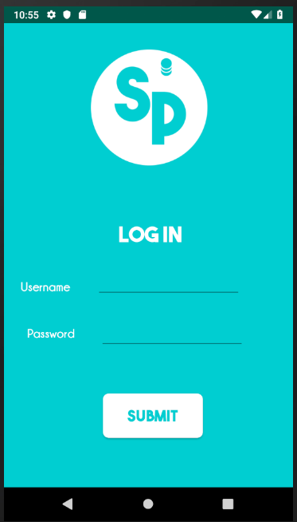

Login Page

Once a user is at the login screen, they can enter their username and password, and sign into the app.

# Menu:

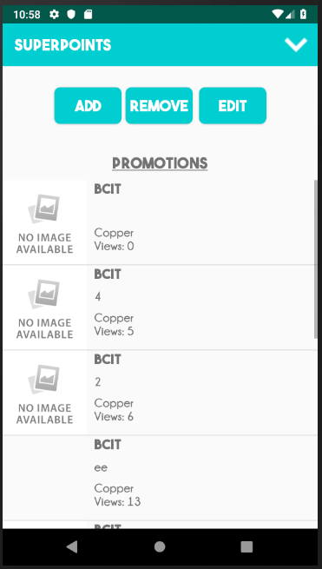

Menu

Users, Business Users, and the Admin all have access to a menu that they can access. The menu is located at the top right, with the icon of a silhouette of a person, which the user can click on to see all of the pages that they can access.

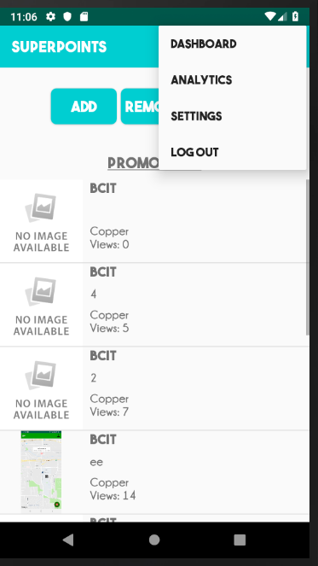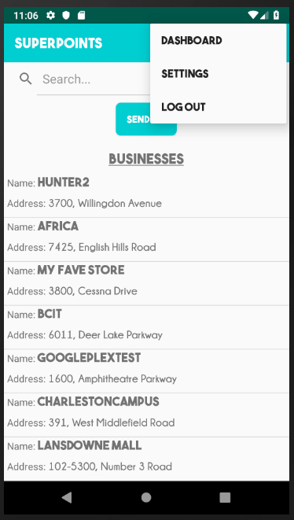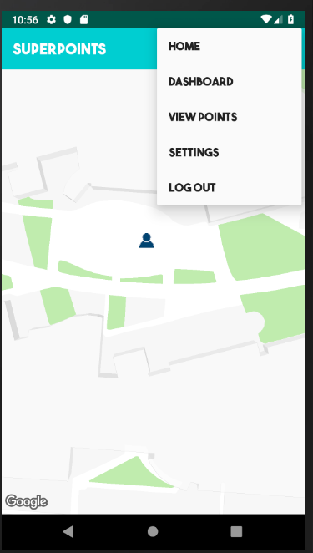

A Business User's Menu An Admin's Menu A User's Menu

A business user can access their dashboard, analytics, and the settings page.

An admin can access their dashboard and settings.

A user can access their home, dashboard, points, and settings page.

# User:

# Home:

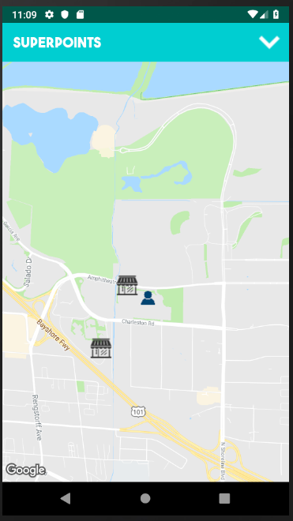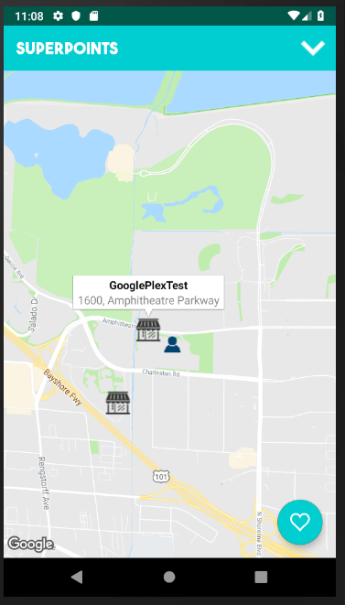

A User's Homepage Business Details

The homescreen of the user is a map that shows their current location. The person icon is where the user is currently located, and the shop icon indicates a business. Clicking on a business will display the business name, the business address, and a heart icon on the bottom right. This icon will allow a user to favorite a business, which will move promos from these business to the top of the user’s promotion list.

The user will also see a dropdown notification when they are near 200m near a SuperPoints business.

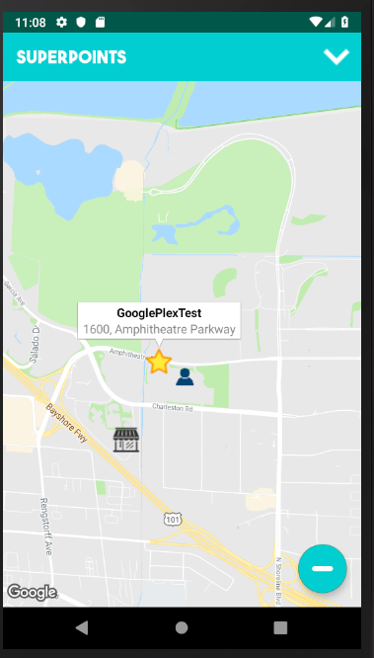

Favoriting a Business

After the user “favourites” a business, the business icon will turn into a star.

# Dashboard:

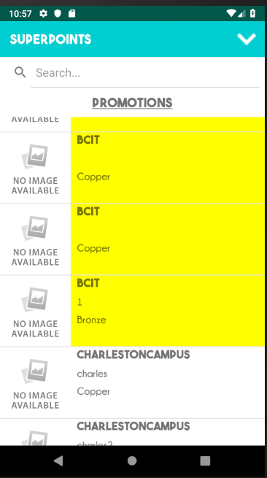

A User's Dashboard

On the dashboard, the user can see all of the promos that they qualify for. If they have set a business to “preferred”, then the promos from that business will be highlighted yellow and moved to the top of the list.

# View Points:

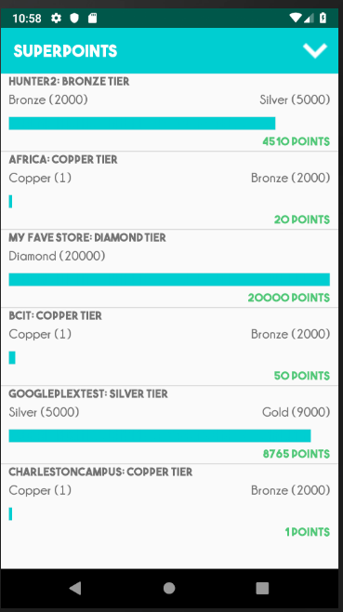

A User's Points Page

On this page, users can see how many points they have for each business that they have visited, as well as how close they are to the next tier.

# Settings:

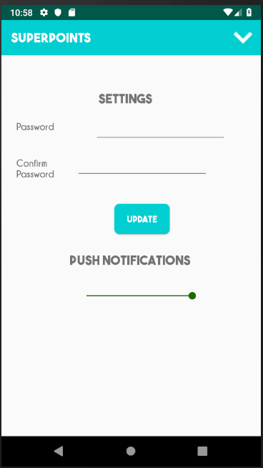

A User's Settings Page

On this page, users can change their password, as well as set their privacy settings. A privacy setting of 0 means that the user will receive the least amount of notifications from this app.

# Business:

# Business Dashboard:



A Business Dashboard

The dashboard is the first screen that a business user will encounter when they log into the app. On the dashboard, a business user can add, remove, edit, and view their promotions.

# Adding a Promotion:

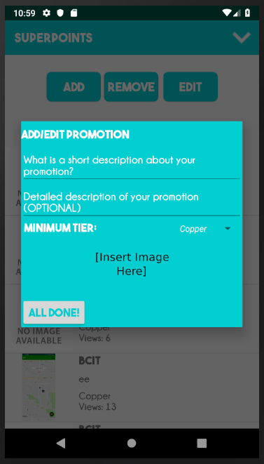

Adding a promotion

Clicking on the ‘Add’ button allows a business user to create a new promotion. A promotion consists of a short description, an optional detailed description, and an optional image of the promotion. The business user can also select the minimum tier that a user needs to be in order to view this promotion.

The tiers are as follows:

Copper – 1 point

Bronze – 2,000 points

Silver – 5,000 points

Gold – 9,000 points

Platinum – 14,000 points

Diamond - 20,000 points

# Editing a Promotion:

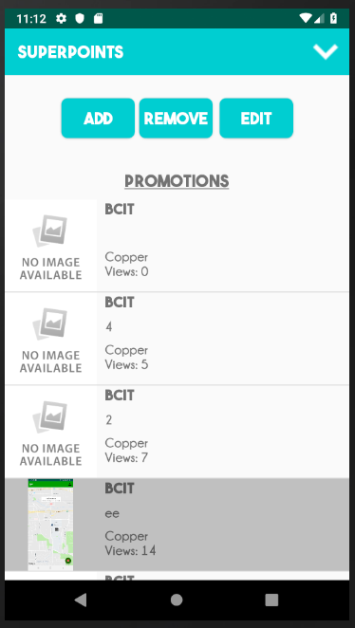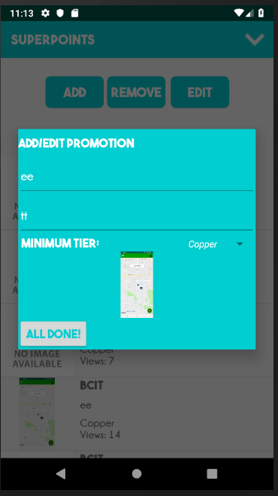

Selecting a Promotion Editing a Promotion

If a business user clicks on a coupon and presses the edit button, they will be able to edit an existing promotion.

# Deleting a Promotion:

Selecting a promotion and clicking on the ‘Delete’ button will allow a Business user to delete an existing promotion.

# Analytics:

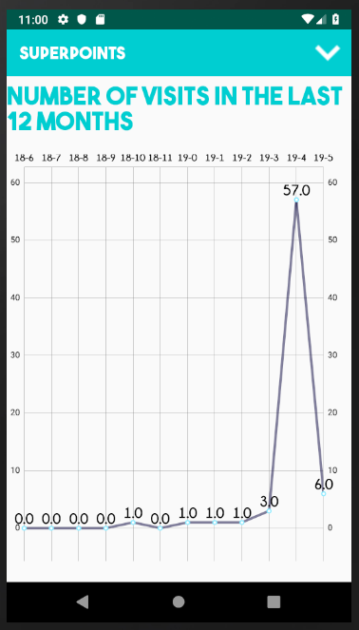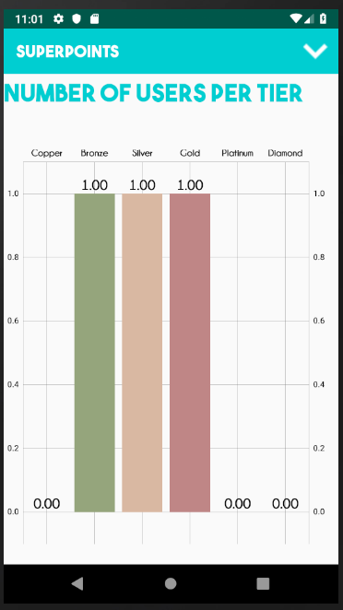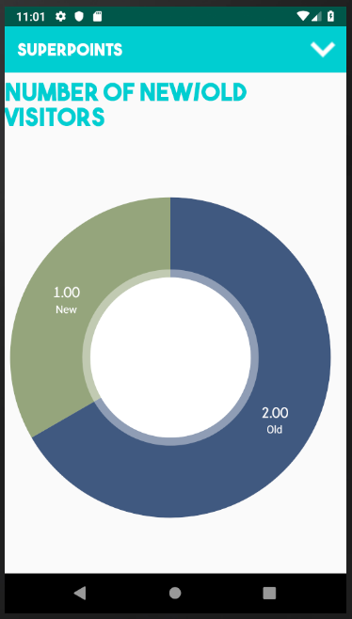

# of visits in the last 12 months # of Users Per Tier # of New vs Old Visitors

On the analytics page, a business user can see some statistics and analytics about their business. In order to see the other statistics, the user can swipe left or right. There are three analytics that a business user can see:

1. Number of users who have visited their store in a month, for the last 12 months. This is shown in the format of a line graph.
2. Total number of visitors per tier (copper, bronze, Silver, gold, platinum, diamond), in the form of a bar graph.
3. Number of new users and old users who have visited their business this month, shown in the form of a pie chart.

# Settings:

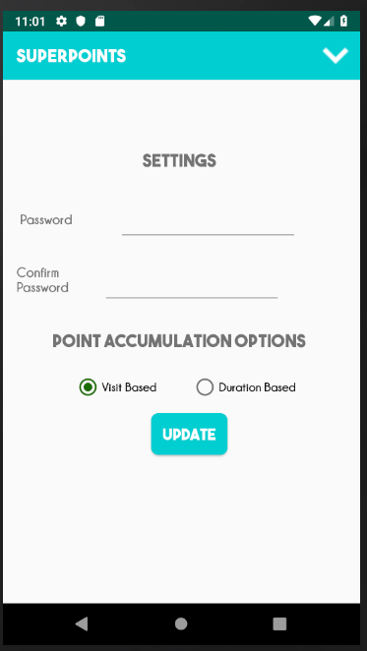

A Business User's Settings

The settings page allows a business user to change their password, as well as change how to distribute points to users who visit their business. The business user can choose to either award points based on a visit based criterion, or a duration based criterion.

If a business user chooses to award points to their customer on a visit based system, then a user of this app will gain 250 points as soon as they visit the store. A “visit” needs to last at least two minutes to count, so that users who are passing by will not get these points. A user will not get any more points than 250 for this visit.

If a business user chooses to award points to their customer based on duration, then the customer will start accumulating points over time. The algorithm for point gain is set up so that the customer starts to receive points slowly, and the rate at which they accumulate points will increase until the 20 minute mark, after which it will start to decay again. In short, this means that the customer will receive the maximum amount of rewards for being in the store for about 20 minutes. If a customer is in the store for less than 20 minutes, or longer than 20 minutes, they will still receive points, but the point gain will be slow.

# Admin:

# Dashboard:

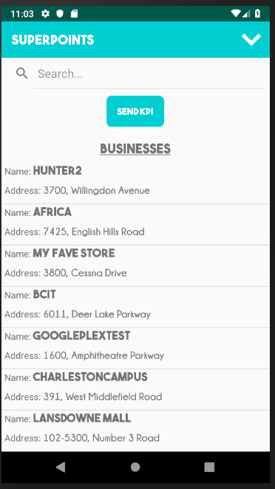

An Admin Dashboard

On the dashboard, the admin will be able to see all of the businesses that have signed up with SuperPoints and their addresses.

# Beacon Setup:

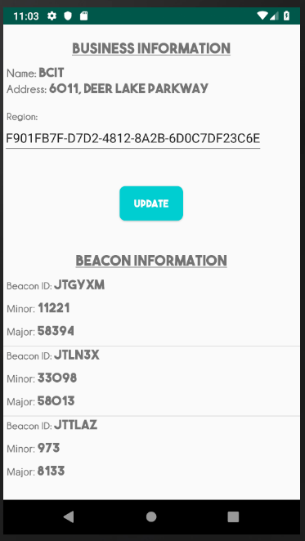

Business and Beacon Details

Clicking on a business in the dashboard will open up this page, which will display the beacon information about the business. The admin can also enter the region ID of the beacon here.

Note: The admin needs to also add the region ID of the beacon on the Kontakt website.

# Settings:

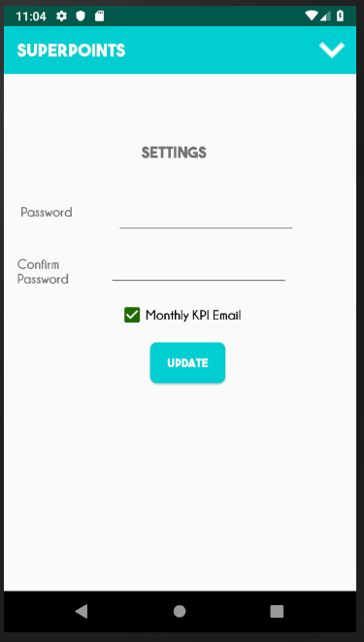

Admin Settings

On the settings page, the admin is able to change their password, as well as select the “Monthly KPI Email” option. If this option is checked, the admin will receive an email on the last day of each month with the KPI of all the businesses for that month.